Gebze Technical University
Computer Engineering

CSE 222/505-Spring 2021
Homework 4 Report

Mevlüt Reha İnan
151044045

1.System Requirements
Creating min-heap structre.We represent binary tree as an Arraylist all. All indexes has parent index , left child index and right child index.Parent child index is “(index-1)/2”,Left child index is “(Index*2)+1” and right child index is “(Index*2)+2” we represent a three with an array.Its more usefull than tree because of we can reach child or parent with an formula instead of stepping up nodes.

2.Class Diagram
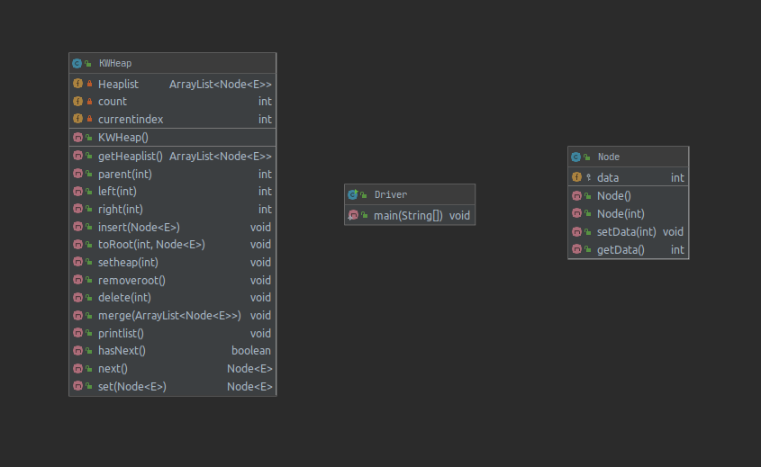

3.Problem Solution Approach

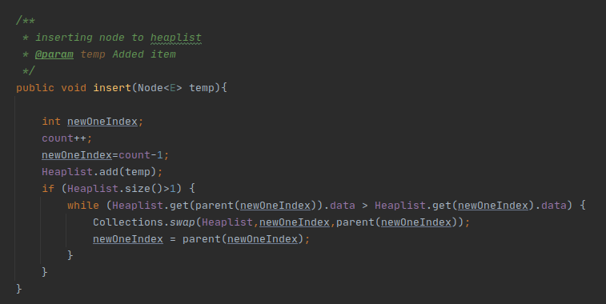
Adding temp node to list and swapping if parents smaller than new item until its ready.
O(n)

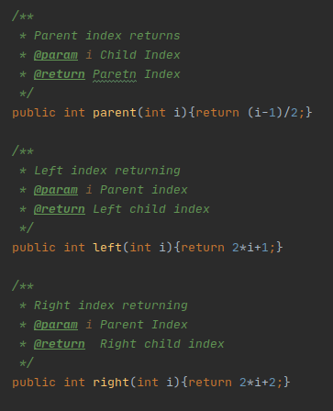

Parent and left right child formulas.

T(1)

T(1)

T(1)

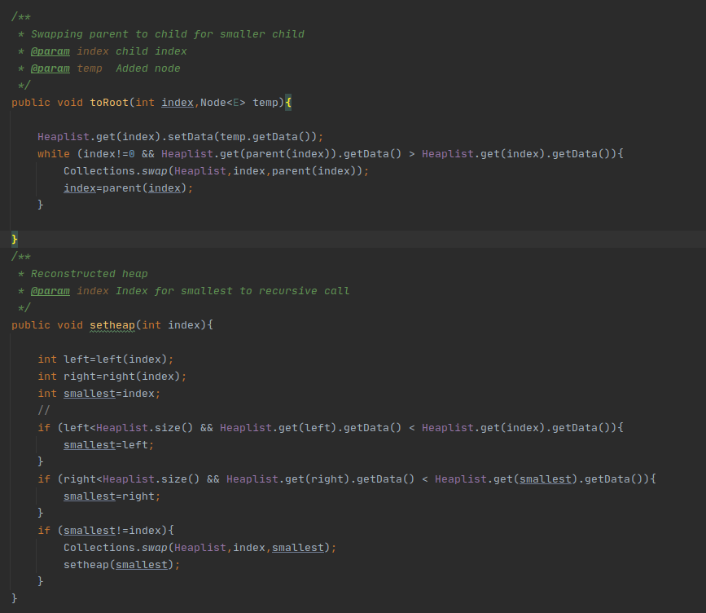

Given nodes
swapping with his parent until to root because of we want to delete this node.

O(n)

Setting heap and swapping parents and childs with recursive.We want minimum value must be on top.
O(n)

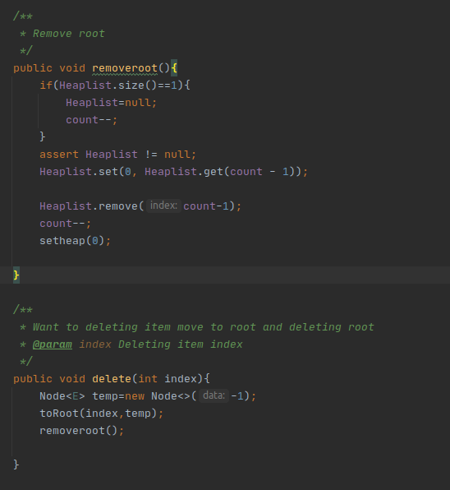

Removing root.O(n)

Setheap O(n)

Deleting node from its index.First this node goes to top(root) and deleting root.
O(n+n)=O(n)

4 Running commands and results
